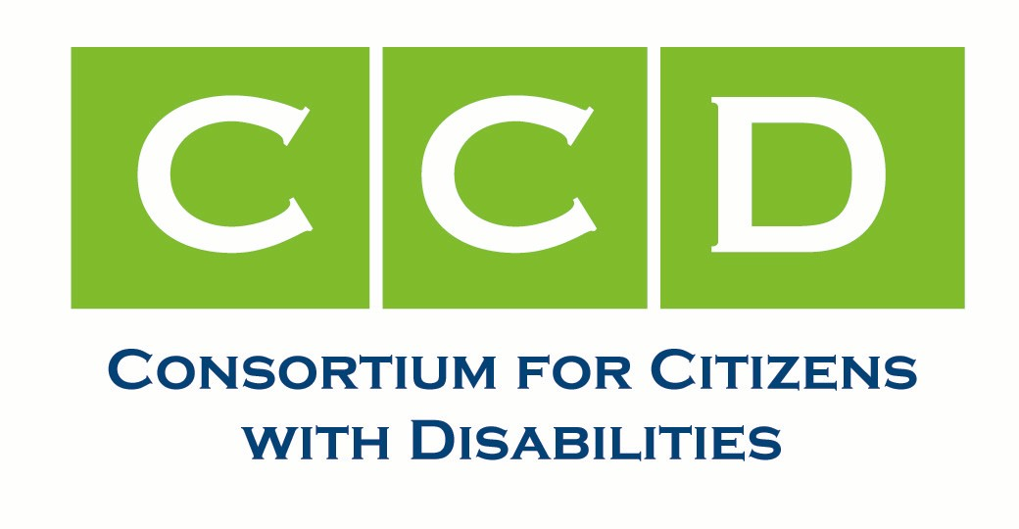

November 17, 2011
RE: Restore Funding to IDEA and Ensure No Further Cuts
Dear Appropriations Subcommittee Member:
The undersigned organizations of the Consortium for Citizens with Disabilities are writing to express our concerns about what we believe was an unintentional cut to the Individuals with Disabilities education Act (IDEA) and three other programs in the continuing resolution (CR) expiring November 18th. In any future appropriations bill, we urge you to correct this reduction by providing the funds that were cut to all four programs - a total of $329 million - and ensure that there are no further cuts to any of these programs caused by this calculation.
The current FY 2012 CR, which funds the government through November 18, 2011, contains an approximate 1.5 percent across-the board cut for all programs. Since most education programs are forward funded, meaning states and school districts do not receive FY 2012 funds until July 2012, this cut appeared to have little impact on education programs. However, for - IDEA, Title I, Title II, and Career and Tech Programs - this is not case.
The problematic language that results in us reaching this conclusion is in Section 115 of the CR which states, “[d]uring the period covered by this Act, discretionary amounts appropriated for fiscal year 2012 that were provided in advance by appropriations Acts shall be available in the amounts provided in such Acts, reduced by the percentage in section 101(b).” Because the FY 2011 full year CR provided advanced appropriations for these four education programs and appropriated funds for these programs that became available on October 1, 2011, the U.S. Department of Education and the Office of Management and Budget have interpreted Section 115 to mean that Congress intended to cut the FY 2011 advanced appropriations to these four programs by 1.5 percent. As a result of this statutory language and interpretation, states received $329 million less for these programs on October 1, 2011, which results in $329 million less for the 2011-12 school-year..
CCD believes that Congress did not intend to cut these programs. During consideration of the FY 2012 CR, there was no indication that the 1.5 percent cut would result in a year-long cut in this school year for these four programs. Additionally, the House of Representatives has proposed an increase in IDEA for FY 2012 and the Senate has not proposed a decrease. Congress should restore the funding that was inadvertently cut and ensure that going forward – especially if there is a full year CR -- it will not result in even greater cuts to any of the four programs, including IDEA.
We urge you to correct this situation and ensure that our schools receive the funds they need.
Sincerely,
Council for Exceptional Children
National Center for Learning Disabilities
National Disability Rights Network

The Consortium for Citizens with Disabilities is a coalition national consumer, advocacy, provider and professional organizations headquartered in Washington, D.C. Since 1973, the CCD has advocated on behalf of people of all ages with physical and mental disabilities and their families. CCD has worked to achieve federal legislation and regulations that assure that the 54 million children and adults with disabilities are fully integrated into the mainstream of society. For additional information, please contact:
Katy Beh Neas, Easter Seals 202.347.3066 kneas@easterseals.com
Laura Kaloi, National Center for Learning Disabilities 703.476.4894 lkaloi@ncld.org
Cindy Smith, National Disability Rights Network 202-408-9514 ext. 101 cindy.smith@ndrn.org

