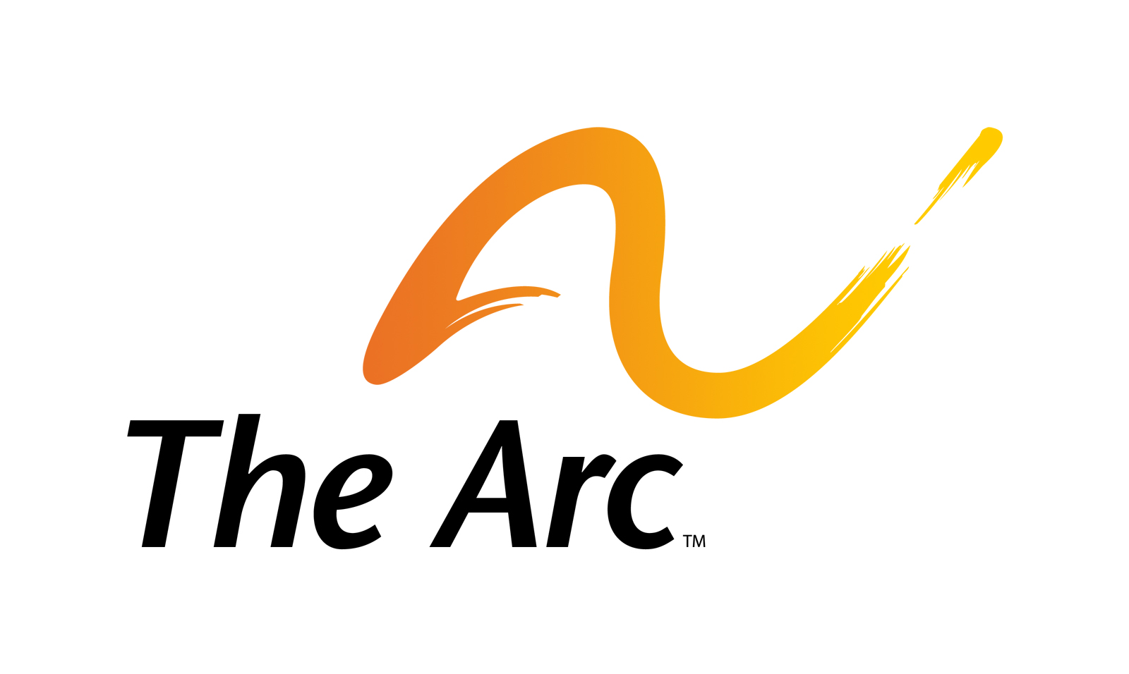
Board Committees and Advisory Councils – 2013

PREAMBLE

The mission of The Arc is to promote and protect the human rights of people with intellectual and developmental disabilities and actively support their full inclusion and participation in the community throughout their lifetimes. To accomplish that mission, the Board of Directors, management and staff work in partnership, actively involving volunteer and staff leaders from among The Arc’s state and local chapters.

The Board of Directors is primarily responsible for governance, including determining the organization’s mission, adopting a strategic plan, determining policies and positions, raising financial and other resources, exercising financial and management oversight and monitoring the organization’s progress toward achieving the mission. The Chief Executive Officer shares leadership responsibility with the Board and is primarily responsible for developing the organizational structure and capacity, and the specific programs and services that further the organization’s mission. The Chief Executive Officer is responsible for supervision and management of the staff of the organization.

To assist in fulfilling its responsibilities, the Board of Directors relies on the work of Board Committees. In most cases, Board Committees provide advice, counsel and wisdom to guide the Board in its decision making. The committees recommend policies or courses of action to be approved by the Board. In some cases, the Board delegates to committees the responsibility to make final decisions on behalf of the Board.

All Board Committees of The Arc are ultimately responsible to the Board. While they focus primarily on a specific area, they must also maintain an awareness and sensitivity to the mission and program of The Arc and act in accordance with applicable policies.

In order to build a strong movement of individuals with I/DD and their family members, The Arc also has established two Councils, the National Council of Self Advocates and the National Sibling Council. These councils provide advice and counsel to inform the advocacy, programs, services and supports of The Arc at the national, state and local level. Membership in these councils is open to anyone interested in participating.

In 2013, The Arc is seeking individuals to participate in the following committees and advisory councils.

Board Committees – 2013

Board Development Committee

Roles and Responsibilities: The Board Development Committee is responsible for assuring that the composition of the Board of Directors of The Arc meets the current and future leadership needs of the organization. The committee biennially establishes nominating priorities, conducts outreach to identify potential candidates to apply for nomination to the board, screens and evaluates applicants in relation to the nominating priorities, and recommends a single slate of candidates for election. The committee also recommends board members to serve as the officers of the corporation. The Board Development Committee is further responsible for ongoing evaluation, training and leadership development.
Chair: Mohan Mehra, Immediate Past President

Committee Membership: As established in the bylaws, the committee is composed of no fewer than six members, including the Immediate Past President of The Arc and the Immediate Past-Chair of the NCE Steering Committee. At least two-thirds (2/3) of the members of the Board Development Committee shall be persons who are not currently serving and have not previously served on the Board of Directors. The committee must include at least one member who is a board member, and at least one member who is a chief executive officer or other senior-level staff, of a state or local Chapter of The Arc.

Meeting Schedule: The Board Development Committee meets by audio and web conferencing. The frequency of meetings varies during the course of the board nominating cycle. During 2013-2014 it is likely that the committee will meet twice between March and August 2013, monthly beginning in September 2013 and at least once a month beginning in January 2014. As the deadline for submitting nominations (e.g. 30 days in advance of 2014 annual meeting) approaches, the committee may meet twice a month.

To Apply: http://fs16.formsite.com/u024508129ncearc/form69/index.html

Budget, Finance And Audit Committee

Roles and Responsibilities: The Budget, Finance and Audit Committee is responsible for oversight of The Arc’s financial health. The Committee reviews and recommends approval of the annual budget, monitors financial performance and legal and regulatory compliance, retains the independent auditor and oversees the annual audit of the organization’s financial statements and develops and provides oversight regarding other financial policies and practices. The Committee is responsible to assure that the annual audited financial statements are presented to the Board of Directors. The Committee also annually reviews the performance of The Arc’s investments and recommends any changes to The Arc’s Investment Policy.

Chair: MJ Bartelmay, Treasurer

Committee Membership: As established in the bylaws, the committee is composed of no fewer than six members, including the Treasurer who serves as chairman. The committee must include at least one member who is a board member, and at least one member who is a chief executive officer or other senior-level staff, of a state or local Chapter of The Arc.

Meeting Schedule: The Budget, Finance and Audit Committee generally meets 3 times/year (March, July & October) by audio and web conferencing.

To Apply: http://fs16.formsite.com/u024508129ncearc/form69/index.html

Policy And Positions Committee

Roles and Responsibilities: The Policy and Positions Committee is responsible for recommending to the Board of Directors the positions of The Arc on issues of concern to people with intellectual and developmental disabilities and their families consistent with the Core Values of the organization. Positions of The Arc are articulated in written position statements, and brought to life through The Arc’s legislative and regulatory advocacy, as well as through litigation. The committee’s primary responsibility is to develop The Arc’s Position Statements and Public Policy Agenda, with broad input from chapter leaders as well as experts in the field, including both identifying and developing new statements and revising and updating existing statements. The Committee facilitates the full Board’s involvement in development of the Position Statements and Public Policy Agenda and, once completed, recommends their formal approval in the manner described in the Bylaws.

A Legislative Agenda Subcommittee is responsible for developing, on a biennial basis corresponding to the term of Congress, a Legislative Agenda that is consistent with the Core Values, Position Statements and Federal Public Policy Agenda. The Legislative Agenda Subcommittee also recommends positions on new issues that are otherwise not covered by the Public Policy Agenda.

A Legal Advocacy Subcommittee is responsible for determining whether The Arc should become involved in litigation (typically as an amicus curiae) and the positions to be taken consistent with the Core Values and Position Statements.

Co-Chairs: To be named

Committee Membership: As established in the bylaws, the committee is composed of no fewer than six members. The committee must include at least one member who is a board member, and at least one member who is a chief executive officer or other senior-level staff, of a state or local Chapter of The Arc.

Individuals with professional or volunteer experience lobbying at the national or state level are encouraged to apply for the full committee. Attorneys with criminal or civil litigation experience are needed for the Legal Advocacy Subcommittee.

Meeting Schedule: Generally, the work of the Policy and Positions Committee is planned to take place over a two year cycle, with the even numbered calendar year devoted to review and revision of the Public Policy Agenda and Legislative Agenda, and the odd numbered calendar year devoted to review and revision of, or creation of new, position statements. The full committee meets 2-3 times a year, with additional meetings of sub-committees and work groups as needed; meetings are held by audio and web conferencing call.

To Apply: http://fs16.formsite.com/u024508129ncearc/form69/index.html

Resource Development Committee

Roles and Responsibilities: The Resource Development Committee is responsible for expanding The Arc’s philanthropic support from individuals, foundations and corporations, with an emphasis on unrestricted support. It sets the pace and leads The Arc’s three fundraising campaigns: (1) Board of Directors Annual Fund Campaign, (2) Major Donor Campaign, and (3) Corporate Campaign. Committee members serve on the campaign cabinets responsible for leadership and oversight of the campaign and are actively involved in identifying and cultivating major donor and planned giving prospects, as well as developing leads for potential foundation and corporate support, including corporate sponsorships. Cabinet members also lead and participate in outreach efforts to state and local chapters leaders to identify individual, national foundation, and Fortune 500 companies that should be cultivated to support The Arc at multiple levels of the organization.

Co-Chairs: To be named.

Committee Membership: The Resource Development Committee is a committee of the whole Board of Directors. In addition to giving to the Board of Directors Annual Fund Campaign, board members elect to participate on the campaign cabinet for the Major Donor Campaign, the Corporate Campaign, or both. Individuals who are, or who represent, major donors or corporate donors participate by invitation only.

Meeting Schedule: The Resource Development Committee and Campaign Cabinets meet as needed by telephone and/or web conferencing.

Special Committees - 2013

Committee on Diversity

Roles and Responsibilities: The Committee on Diversity is being newly formed to advance The Arc’s longstanding commitment to diversity (including but not limited to race, ethnicity, religion, age, geographic location, sexual orientation, gender and type of disability) as expressed in the Core Values and Guiding Principles and the Strategic Framework for the Future of The Arc, 2010 – 2019. The Committee will provide a forum to research, monitor, discuss, and address national diversity issues and trends and their impact on The Arc at all levels, as well as the relevance and effectiveness of The Arc in an increasingly diverse society. The Committee will also explore how best to encourage and facilitate diversity at all levels of The Arc in leadership, workforce, membership, and among the individuals and families with I/DD that we serve and other facets of the work of the organization.

Chair: Ron Brown

Committee Membership: To be appointed by the President.

Meeting Schedule: The Committee on Diversity will have 1-2 meetings by telephone and web conferencing during the first six months of 2013, during which time it will further define its workplan, timeline and meeting schedule for 2013 and 2014.

To Apply: http://fs16.formsite.com/u024508129ncearc/form69/index.html

Advisory Councils - 2013

As described in The Arc’s Bylaws, in order to build a strong movement of parents, siblings, other family members of people with I/DD, of individuals with I/DD themselves, and of the professionals leading the organizations that serve and support them, The Arc has established a national self-advocates council and a national siblings council. These councils provide advice and counsel to inform the advocacy, programs, services and supports of The Arc at the national, state and local level.

National Council of Self-Advocates

About the National Council of Self-Advocates (NCSA): The NCSA was developed to foster the active involvement of individuals with I/DD in the work of The Arc. Its primary purpose is to empower persons with I/DD to voice their opinions about what is important to them and to ensure that they are afforded the same opportunities as everyone else to have a meaningful life in the community. In joining the Council, members will be able to network with others who are involved in advocacy work, educate the public about the issues that are important to people with I/DD, and become active leaders in their communities. In addition, the Council will also be promoting leadership roles for individuals with I/DD in local chapters of The Arc and supporting The Arc’s commitment to employing individuals with I/DD.

Co-Conveners: Barbara Coppens, Joe Meadours, Kurt Rutzen, national board members.

Meeting Schedule: The National Council of Self-Advocates will meet 2 - 3 times/year, with meetings held by telephone and web conferencing. Informal, face-to-face meet-ups will take place, where possible, at other gatherings, such as the National Convention.

Membership: Membership in the NCSA is free to members of The Arc at the local, state and national level.

To Join the National Council of Self-Advocates: http://www.thearc.org/page.aspx?pid=3508

National Sibling Council

About the National Sibling Council: The NSC was developed to foster the active involvement of brothers and sisters of individuals with I/DD in the work of The Arc. Its primary purpose is to connect siblings as an important segment of the disability movement to impact policy, service delivery, and the quality of life for the millions of Americans with I/DD. The Arc’s new sibling initiatives will also provide the necessary support to siblings who are looking for resources and answers to questions unique to them and their family’s future. In addition, the Council will also be promoting leadership roles for siblings of people with I/DD in local chapters of The Arc.

Co-Conveners: Nancy Webster, national board president, The Arc; Amberley Romo, national staff, The Arc; Erica Smothers, member, The Arc of East Central Iowa; Shea Tanis, Vice-chair, Sibling Leadership Network.

Meeting Schedule: The National Siblings Council will meet 2 - 3 times/year, with meetings held by telephone and web conferencing. Informal, face-to-face meet-ups will take place, where possible, at other gatherings, such as the National Convention.

Membership: Membership in the NSC is free to members of The Arc at the local, state and national level.

To Join the National Siblings Council: http://www.thearc.org/page.aspx?pid=3407

