Santa Perez Biography

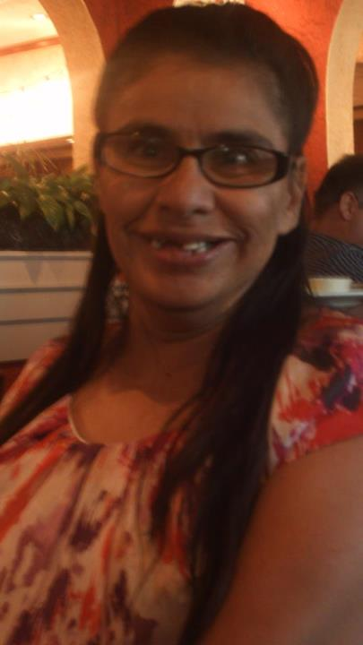
Santa Perez is from Southern California where she was very active in the self advocacy field. She earned her Bachelors of Arts degree in Psychology from Cal State Northridge.

When Santa moved to Las Vegas in the mid 90`s she discovered that there were no advocacy groups for people with disabilities. This was unacceptable for Santa and she started her quest to bring a self-advocacy group to Nevada.

Santa completed the Partners in Policy Making program in 1999 at The University of Nevada, Reno. Their UCEDD had just started a new project, AmeriCorps Vista (Volunteers in Services to America), and she was informed that they wanted her to become a member. This became her golden opportunity to fulfill her goal of bringing a self-advocacy group to Nevada. Through this project, Santa co-founded People First of Nevada and her dream is now a reality with 7 chapters all around the state. Santa is a very proud and active President of the People First of Nevada. She has testified before the state legislation and was instrumental in getting the Signature Stamp Law and the People First Respectful Language Law passed.
In her personal life Santa has accomplished many things. She has her own home and is a part of her community, but in her eyes, her greatest accomplishment is her son Noah.

Santa is currently working for NECDD and The Arc of Nevada as an Advocate Coordinator. She has given many presentations at national conferences around the country.
Santa’s favorite saying is “disability does not negate humanity, it’s that human touch”.

