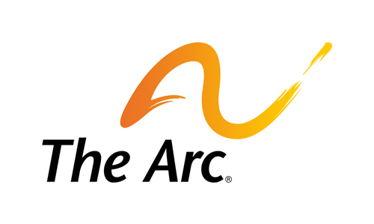 Civil Rights
Rights
During the 115th Congress, our public policy goals are to:
- Protect against forms of discrimination based on disability, ethnicity, race, sex (including pregnancy, gender identity and expression, and sexual orientation), religion, familial status, age, language, national origin, genetic information, or any other protected status.
- Protect and promote stronger enforcement of existing civil rights laws for people with disabilities, particularly the Americans with Disabilities Act; Individuals with Disabilities Education Act (IDEA); Fair Housing Act; Civil Rights of Institutionalized Persons Act (CRIPA); the Rehabilitation Act; Help America Vote Act (HAVA); National Voter Registration Act (“motor voter”); Matthew Shepard and James Byrd, Jr. Hate Crimes Prevention Act; Genetic Information Nondiscrimination Act; Air Carrier Access Act; and Section 1557 of the Patient Protection and Affordable Care Act;
- Protect the authority of and increase funding for federal government entities that enforce disability rights laws, including the Equal Employment Opportunity Commission (EEOC), and civil rights offices in the Departments of Justice, Health and Human Services, Housing and Urban Development, Labor, Education, Homeland Security, and Transportation;
- Recognize and respect supported decision-making agreements;
- Protect, enhance, and ensure adequate funding for federal protection and advocacy programs for people with disabilities;
- Preserve and enhance legislation and social programs that protect the rights of children and youth with disabilities, particularly those who are served by foster care systems;
- Prohibit the use of aversive interventions including, chemical and mechanical restraints. Prohibit the use of physical restraint or seclusion where a person does not pose an immediate danger to themselves or others. Support sanctions for use of restraint or seclusion outside of those emergent situations;
- Provide protection and oversight for cases of abuse and neglect as well as provide training to prevent abuse and neglect;
- Ensure that legislation addressing issues such as physician-assisted suicide, stem cell research, end-of-life care, organ transplants, and research on human subjects includes protections against abuse and discrimination on the basis of disability; and
- Promote and protect equal rights of children and adults with disabilities in all parts of the world, by supporting the ratification of the UN Convention on the Rights of Persons with Disabilities (CRPD).

Voting Rights Reform
People with disabilities, individually and collectively, offer an important and needed voice in our nation. Ensuring voting independence, accuracy, and access continue to be key issues for this constituency. The Help America Vote Act (HAVA) required fully accessible voting machines for people with disabilities by January 1, 2006. This promise has not been fulfilled. Too many polling places voting technology throughout the country remain inaccessible.
During the 115th Congress, our public policy goals are to:
- Provide strong enforcement of and adequate funding for HAVA to address the right of people with disabilities to vote privately and independently in any federal election, to rectify continuing failures to meet the provisions of the law, and to make recommendations for improvement;
- Ensure that any new voting reform legislation provides equal and full access to voting systems and polling places for voters with disabilities and does not disenfranchise voters with disabilities regardless of their guardianship status;
- Ensure that requirements for voter identification and/or voting technology do not hinder or discourage voting by people with disabilities; and
- Incentivize automatic voter registration when receiving a driver’s license or state ID card.

To download the full legislative agenda, visit: http://www.thearc.org/what-we-do/public-policy/legislative-agenda

