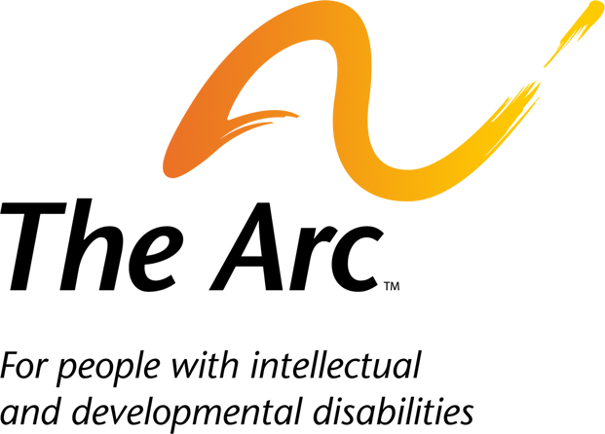

Request for Proposal Announcement –
Research on Paid Family and Medical Leave

Application and budget due: February 6, 2018

Expected program period: March 1, 2018 through March 31, 2019

Purpose:

The Arc of the United States (The Arc) seeks an experienced research entity to design, implement, and analyze quantitative and qualitative interviews with people with disabilities and their families to explore:
- Common reasons that workers with disabilities and family caregivers of adults and children with disabilities take family and medical leave, their patterns of leave-taking, the positive effects of access to paid family and medical leave, and unmet needs for paid leave;
- How gaps in access to paid leave affect family economic security, employment, and health and disability outcomes; and
- Optimal parameters for proposed paid family and medical leave policy elements, such as the duration of leave, wage replacement level(s), definition of family, qualifying events, and features of intermittent leave.

The contractor will be responsible for the following activities:

- Working with The Arc and the review panel (described below) to develop specific research questions.
- Conducting the research in compliance with the ethical standards and the criteria for approval and conduct of research set forth in United States Department of Health and Human Services policy for the protection of human research subjects (45 C.F.R. Part 46 and related guidance) and all other federal and state laws applicable to the research project, including obtaining and maintaining institutional review board (IRB) approval and obtaining informed consent of participants. The contractor will be responsible for handling all aspects of the IRB process.
- Designing one-on-one structured interviews and interview protocols to explore the research questions with 3 subpopulations: workers with disabilities, caregivers of minor children with disabilities, and family members providing supports to adults with disabilities.
- Providing stipends to research participants.
- Recruiting participants and conducting one-on-one interviews with at least 30 members of each subpopulation (at least 90 interviews total). Every attempt will be made to engage a mix of interviewees from rural and urban communities and with diverse backgrounds.
- Creating a database and conducting quantitative and qualitative analysis of structured interview data.
- Preparing a draft report (October 15, 2018) that includes an Executive Summary and a technical report of all findings; reviewing and incorporating feedback from The Arc and the review panel (described below; where appropriate); and producing a final report (December 1, 2018). “Final report” means a Word document with all final text, data tables, and references; The Arc will handle layout for publication the week of February 4, 2019.
- Reviewing and providing feedback on the report layout (December, 2018 – January, 2019).
- Reviewing and providing feedback on a fact sheet prepared by The Arc summarizing the research findings (December, 2018 – January, 2019).
- Developing one presentation on the research and findings, delivered via 2 total webinars or briefings (January-March, 2019).
- Providing monthly updates to The Arc by phone or email (no formal reporting format is required).

To inform the project, The Arc will convene a 10-15 member review panel of stakeholders agreeable to both The Arc and the contractor. Members of the panel will be asked to: (1) review and provide non-binding feedback on draft research questions; (2) review and provide non-binding feedback on the draft report; and (3) assist with dissemination and amplification of the final report, if appropriate. The Arc will manage recruitment and communication with the review panel. The Arc and contractor may provide one 30 minute call for the panel to review the preliminary research findings in October, 2018; otherwise, the panel members will work independently.

The final research report will be co-authored by the contractor and The Arc and may include staff authors if desired by the contractor. Following the conclusion of this project and within 90 days of the completed deliverables, the contractor will provide the original data and database to The Arc, and destroy and/or delete its copies of the data upon request of The Arc. The Arc retains the full rights to the data and publishing rights; any subsequent interest in analyzing or publishing data findings will require further negotiation with and approval by The Arc prior to engaging in such work.

The report release is set for the first week of February, 2019; this deadline is not negotiable by The Arc and is dictated by the timelines of external events and the expectations of other parties. Since other events depend on an on-time completion of the report, all applicants must assure that the research, analysis, and report will be completed by December 1, 2018. Applicants are responsible for providing a competitive bid for this project that realistically reflects the costs of conducting their plan.

The total amount of funding for this contract will not exceed $90,000.

Proposal

Applicants are invited to submit their proposal that includes the following:

Pages 1-4 (maximum)
- An overview of the applicant’s organization and resources related to this project; experience conducting research with people with disabilities and their families, including culturally competent research with participants from diverse backgrounds; and experience with relevant topics such as paid family and medical leave, employment, and/or caregiving.
- A proposed activity plan and timeline, including IRB review and approval.
- A description of the applicant’s capacity to complete the project within the stated timeline and assurances that the project can and will be completed within the stated timeline, including examples of work completed under similar circumstances if applicable.
- Plan for qualitative and quantitative data analysis including statistical methodology.
- Assurances for compliance with ethical and security standards, including assurances the data will remain in the possession of only staff working on the contract and a description of how data will be stored during the project.
- The names and qualifications of staff members who will be engaged in this work, their percentage of FTE, and a description of how supervision for ancillary staff will be provided.

Page 5
- Budget with line items for salaries, wages, indirect costs and other operational costs. The Arc will only allow indirect costs of up to 15 percent.
- Bid should be competitive and reflect the actual costs of analysis.

Page 6 to ….
- Online links to (preferred) or samples of similar work conducted.
- Staff vitae.

Proposals should be limited to 4 pages for the narrative, one page for the budget, and as many pages for the samples and staff vitae as needed.

Criteria for selection include the following evaluation factors: reasonableness of budget; organizational capacity including security assurances; assurances that the project can and will be done within the stated timeline; personnel; samples of similar work; development of specific research questions plan; successful completion of IRB review process assurances; design of structured interviews and interview protocol plan; participant recruitment and interview plan; participant stipend plan; data analysis plan; draft research report plan; final research report plan; presentation plan.

Proposals can be emailed directly to T.J. Sutcliffe, Senior Director of Income and Housing Policy at sutcliffe@thearc.org. Fax copies will not be accepted.

Questions can be directed to Casey Nitsch at nitsch@thearc.org.

Due date for all proposals is 4:00pm Eastern Standard Time February 6, 2018.

