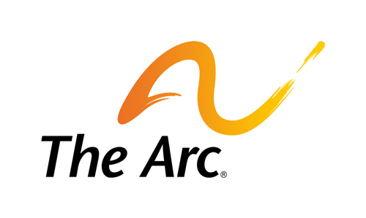

Transportation

Millions of people with disabilities have difficulties obtaining transportation. People often have trouble traveling from place to place because transit systems are unavailable, inaccessible, or not coordinated. Transportation provides a vital lifeline for people with disabilities to access employment, education, health care, and community life. Principles of universal design must be integrated in the development of new transportation devices and projects to ensure greater mobility for people with disabilities.
During the 115th Congress, our public policy goals are to:
- Increase funding for the Federal Transit Administration programs, including mass transit programs (including paratransit), Section 5310 program for the enhanced mobility of seniors and people with disabilities, and other critical programs;
- Effectively implement the Fixing America’s Surface Transportation (FAST) Act provisions impacting people with disabilities;
- Create funding opportunities and supporting technological solutions for coordinated services across jurisdictional lines;
- Expand mobility management and travel training services for individuals with disabilities in order to create more public and private coordinated transportation systems;
- Simplify the coordinated planning process for the programs that serve people with disabilities and creating transparency and accountability at the Department of Transportation;
- Ensure that state and local transportation systems are accessible;
- Promote tax policy that increases access to transportation for people with disabilities;  Ensure accessibility in and around transit locations;
- Promote policies that expand the availability of accessible taxis, ride-sharing vehicles, buses, and other transportation vehicles and systems, particularly for travel in rural and underserved communities and across jurisdictional lines;
- Provide funding to Amtrak to ensure station accessibility and holding Amtrak and other responsible entities accountable for a plan to achieve accessibility;
- Significantly improve air travel accessibility to meet and exceed the ADA standards and provide incentives to the airline industry to comply rapidly;
- Ensure that the Transportation Security Administration (TSA) works with disability advocacy groups to improve TSA’s policies. procedures, and the provision of reasonable accommodations, regarding airport screening that respect the rights and dignity of people with disabilities and expand training of all airport security personnel to follow those policies and procedures;
- Require new federally supported transportation technologies to meet universal design standards; and
- Work toward interstate reciprocity among state para-transit systems so that people with disabilities can travel nationwide.
To download the full legislative agenda, visit: http://www.thearc.org/what-we-do/public-policy/legislative-agenda

