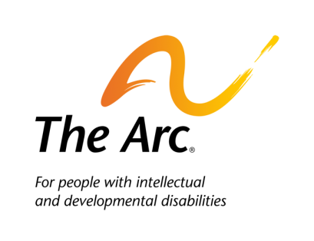

Top Five Reasons the Affordable Care Act
Will Help People with Disabilities

Currently many adults with disabilities and chronic health conditions cannot afford to purchase private health insurance or find that the plans available to them exclude or limit coverage for services they need. This has changed thanks to key provisions in the ACA.

- Elimination of Pre-existing Condition Exclusions: Health insurance companies are not allowed to deny enrollment or specific benefits based on pre-existing conditions. A pre-existing condition is one that existed before the date of enrollment for health insurance coverage and can include common conditions such as diabetes, seizures, asthma, and others.
- Medical Underwriting Disallowed: Health insurance companies will only be able to base premium amounts on age, smoking, size of family and geographic location. Insurers will no long be able to take into account health status when setting premiums. Premiums are the amount people pay to purchase insurance.
- Affordability: Tax credits and cost-sharing reductions will make private health insurance more affordable for low and moderate income individuals (up to 400% of poverty or $46,680 for an individual and $95,400 for a family of 4 in 2014.)
- Essential services: The law requires that plans sold to individuals, small employers and Medicaid Alternative Benefit Plans must cover 10 categories of services. Key categories are:
  - Ambulatory patient services (outpatient care you get without being admitted to a hospital)
  - Emergency services
  - Hospitalization (such as surgery)
  - Pregnancy, maternity, and newborn care (care before and after your baby is born)
  - Mental health and substance use disorder services, including behavioral health treatment (this includes counseling and psychotherapy)
  - Prescription drugs
  - Rehabilitative and habilitative services and devices (services and devices to help people with injuries, disabilities, or chronic conditions gain or recover mental and physical skills)
  - Laboratory services
  - Preventive and wellness services and chronic disease management
  - Pediatric services
- Medicaid expansion: States can now expand Medicaid coverage to adults with incomes up to 133% of the federal poverty level and receive a generous federal match - 100% for the first 3 years and gradually declining to 90% in 2020.

In November 2014, enrollment will began in the new private health insurance marketplaces. To learn more about this program, visit www.healthcare.gov or call the ACA helpline
1-800-318-2596 (open 24 hours a day). The Arc is continuing to update it health care webpage with more information about these critical provisions.

