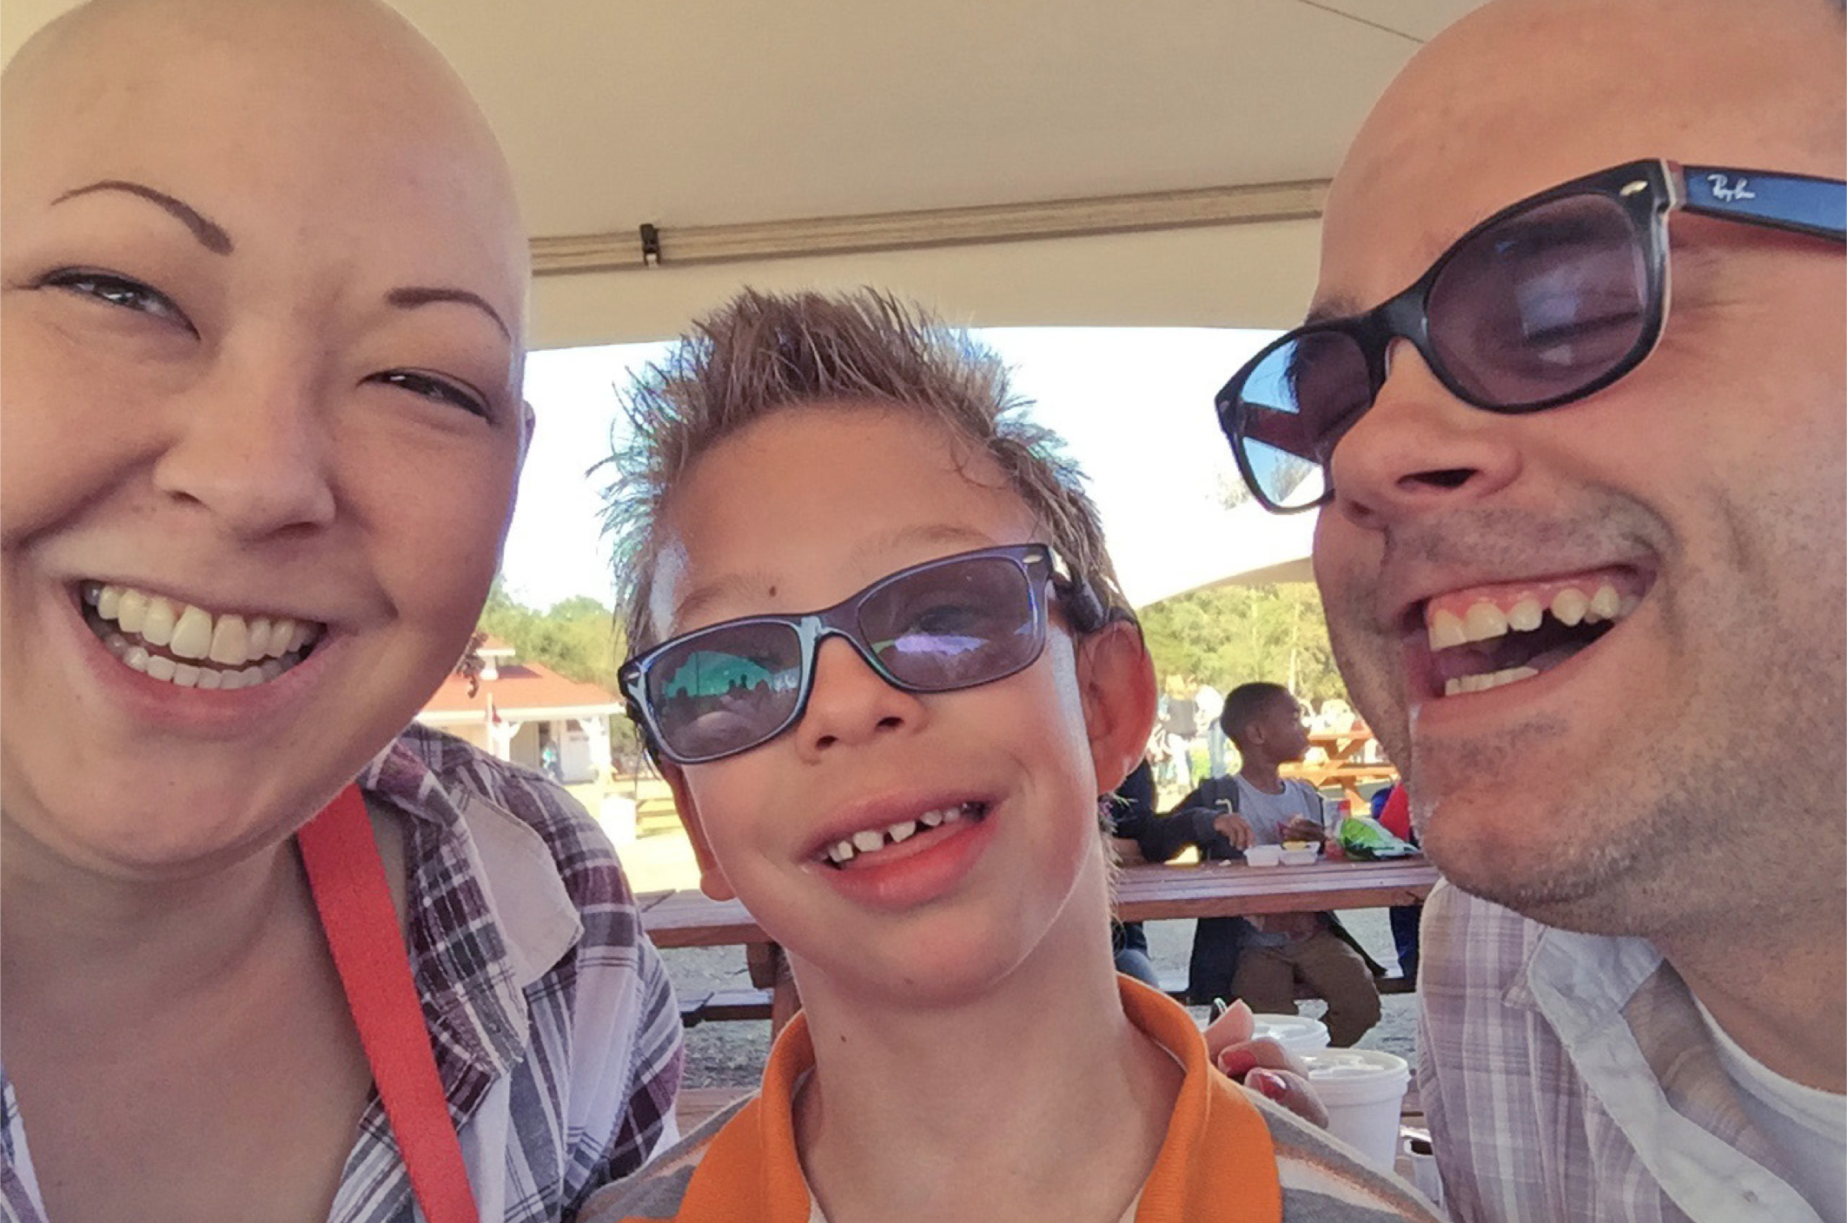

**Study Participants Needed**

If you answered yes, we need to hear from you!

Please call 929-900-5398 or email paidleavestudy@outlook.com with ‘The Arc’ in the subject line to find out if you are eligible!

People who complete a web-based or phone interview will get a $20 gift card.

This project is being conducted by Columbia University and The Arc.

Questions? Contact Suma Setty at ss4358@cumc.columbia.edu.

DO YOU HAVE A DISABILITY OR PROVIDE SUPPORT TO

A LOVED ONE WITH A DISABILITY?

AND HAVE YOU WORKED IN CALIFORNIA, NEW JERSEY, NEW YORK,

OR NORTH CAROLINA IN THE PAST TWO YEARS?