Children’s Health Insurance Program (CHIP) Fact Sheet
What is CHIP?
CHIP currently provides access to health insurance for roughly 8.9 million children up to age 19 in families whose incomes are too high for Medicaid, but for whom employer-based or private coverage is unavailable, unaffordable, or inadequate. Since its bipartisan enactment in 1997, the program has lowered the number of uninsured children from 13.9% in 1997 to 4.5% in 2015.

How is CHIP structured?
- Though CHIP is technically an optional program, all 50 states have chosen to participate.
- CHIP provides states with a set amount of federal matching dollars, regardless of enrollment, to fund their state’s CHIP program. States are then responsible for covering the costs of their CHIP program beyond this federal allotment.
- States can either choose to operate CHIP as an extension of Medicaid, as a program entirely separate of Medicaid, or as some combination of the two.
- This structure means that the various components of CHIP vary from state to state, such as:
  - Income eligibility requirements
  - Whether to cover pregnant women and unborn children
  - Waiting periods
  - Cost-sharing
  - Benefits

What is CHIP’s broader impact?
- When families gain CHIP coverage, the following often occur:
  - Family spending on children’s health care decreases.
  - The likelihood that a family has unpaid medical bills and faces household bankruptcy decreases.
  - Improves access to care, such as annual check-ups, audiology, and dental care.

What is CHIP’s role in the lives of children with intellectual and/or developmental disabilities (I/DD)?
While the exact number of children with I/DD enrolled in CHIP is unavailable, it is clear that individuals with I/DD and other chronic disabilities and chronic health conditions are receiving coverage through the program. It is estimated that 25% of children enrolled in CHIP have special health care needs. Some families of children with I/DD who do not qualify for Medicaid, either because of income or degree of disability status, and do not have access to employer-based insurance may be utilizing CHIP instead.

Why does CHIP need to be reauthorized?
- While CHIP is permanently authorized, federal funding to the states is not. Federal funding expires on September 30th, 2017.
- States can carry over the federal funding which means that some states can keep the program running longer than others.
- An end to federal funding poses a major threat to the future of CHIP, especially in states that may not have the resources, ability, or interest to keep the program running.
- In order for CHIP to continue to function appropriately beyond fiscal year 2017, Congress must reauthorize its funding.

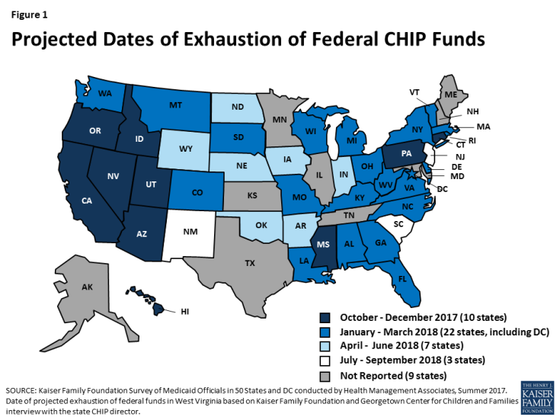

What will happen if federal CHIP funding is not extended?
The Arc urges Congress to renew funding for the Children’s Health Insurance Program (CHIP) as soon as possible so that states can continue their programs without interruption. Research and data suggest that without federal funding, the following will occur:
- States will face budget pressures that will force them to make difficult cuts.
- These cuts may result in a loss of coverage for many children.
- There will be changes to program implementation that will likely increase costs and administrative burdens for states and create confusion and stress for families.

October 4, 2017

