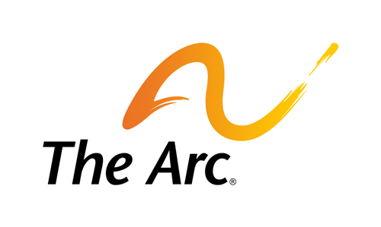

Technology

Many people with disabilities benefit from accessible technology and technology enabled supports to maximize independence. Advances in technologies will continue to affect the lives of people in dramatic ways. These technologies, including commercial off-the-shelf products, can be readily available from a variety of program funding sources, and could help to make services more cost-effective. The 115th Congress should facilitate access to new technology from all sources to support the independence, inclusion, and community participation of people with disabilities.
In particular, the Assistive Technology Act (ATA) of 2004 called for new approaches on the part of programs authorized under the Act to assure that people with disabilities and their families are able to access the assistive technology they need. Funding of the ATA is key to making progress.
During the 115th Congress, our public policy goals are to:
- Ensure that people with disabilities have information about and access to affordable, appropriate, useable, and accessible technology throughout their lifetimes to fully participate in society;
- Protect, enhance, and fully fund all of the provisions of the ATA:
  - State Assistive Technology Act (AT) Programs – Bring every state and territorial program to at least the “minimum allotment” level as defined in the 2004 reauthorization, and, for affected state programs, restore funding that has been lost in recent years. In addition, fully funding the State AT programs would allow states and territories to better support any of the four state-level activities that include device demonstration, device loans, reutilization, and state financing activities, that are in high-demand in their state;
  - Protection and Advocacy for Assistive Technology;
  - National Technical Assistance – to ensure quality technical assistance to each state and territorial program; and
  - Research and Development – to support a meaningful level of research and development of assistive technology devices and standards;
- Promote the adoption of commercial, off-the-shelf, multiple-use technology to support people with I/DD;
- Require the Centers for Medicare and Medicaid Services (CMS) to authorize payment for and issue guidance to states and territories that will result in expanded coverage of appropriate assistive technology and technology-enabled supports, including smart home technologies, for Medicaid beneficiaries, including eliminating barriers to multi-use and commercial off-the-shelf technology that could support independent living in the community

To download the full legislative agenda, visit: http://www.thearc.org/what-we-do/public-policy/legislative-agenda

